LAB No. 15
File Permission and Ownership

Objective
To understand and manage file permissions, ownership, and default permission settings (umask) in Linux using administrative commands.
Learning Outcomes
After completing this lab, students will be able to:
- Interpret Linux file permission symbols and numeric modes.
- Change file and directory permissions using chmod.
- Modify file ownership and group using chown and chgrp.
- Configure default file permissions using umask.
- Understand security implications of permissions.
Lab Requirements
- OS: Ubuntu / CentOS / Rocky Linux
- Access: Normal user with sudo privileges
- Tools: Terminal

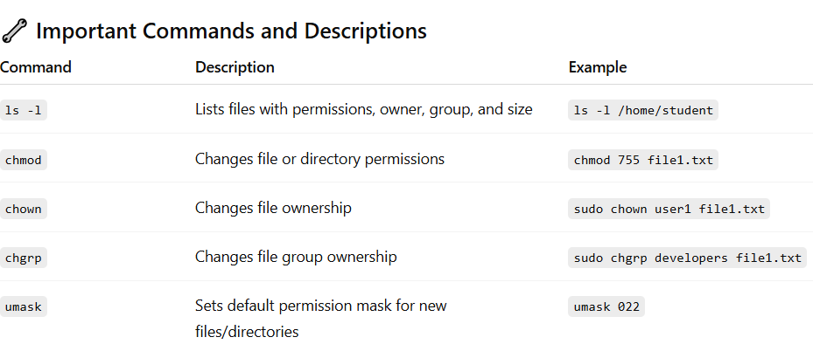

Task 1: View Current Permissions
- Open terminal and create files:
touch file1.txt
mkdir myfolder

- View permissions:

ls -l

Output Example:
-rw-r--r-- 1 student student 0 Oct 16 11:32 file1.txt
drwxr-xr-x 2 student student 4096 Oct 16 11:32 myfolder

- r = Read
- w = Write
- x = Execute
- First 3 characters → Owner permissions
- Next 3 → Group permissions
- Last 3 → Others

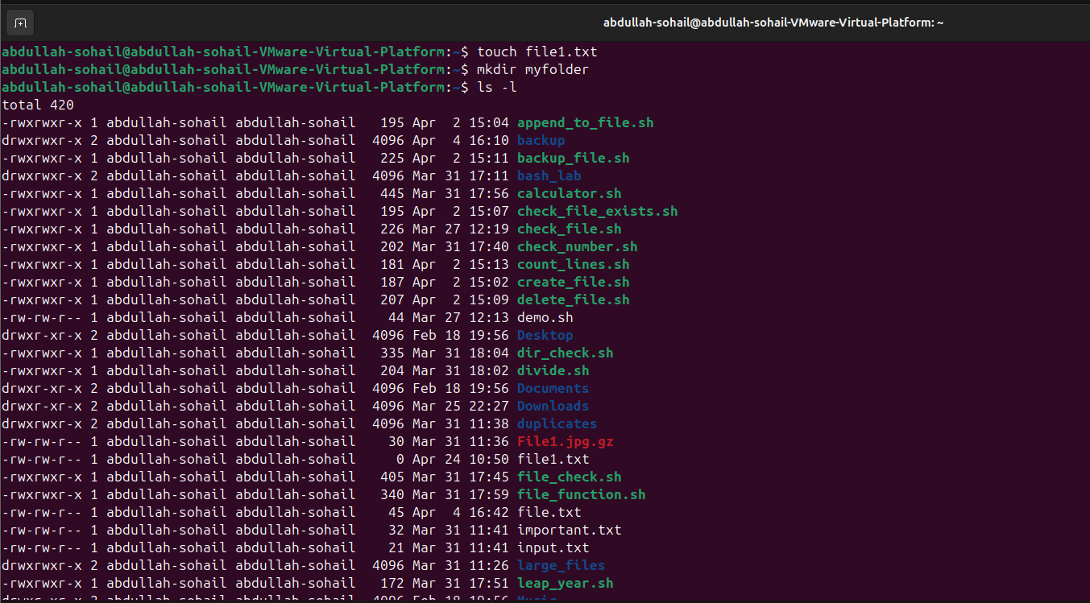

Task 2: Change Permissions Using chmod
  - Symbolic Method:
- chmod u+x file1.txt # Add execute for user
- chmod g-w file1.txt # Remove write for group
- chmod o+r file1.txt # Add read for others
b) Check results:
ls -l file1.txt

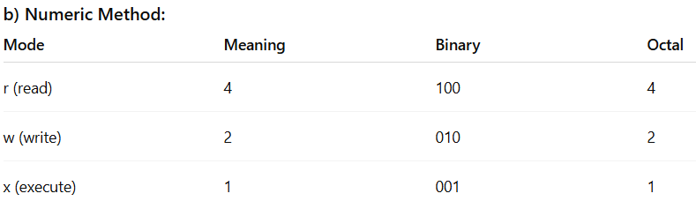
Example:
chmod 740 file1.txt

- Owner: 7 (rwx)
- Group: 4 (r--)
- Others: 0 (---)
Task 3: Change Ownership and Group
- Create a test user and group:

sudo useradd testuser
sudo groupadd devgroup

- Assign file ownership:
sudo chown testuser file1.txt

- Assign group ownership:
sudo chgrp devgroup file1.txt

- Combine both:
sudo chown testuser:devgroup file1.txt

- Verify
ls -l file1.txt

